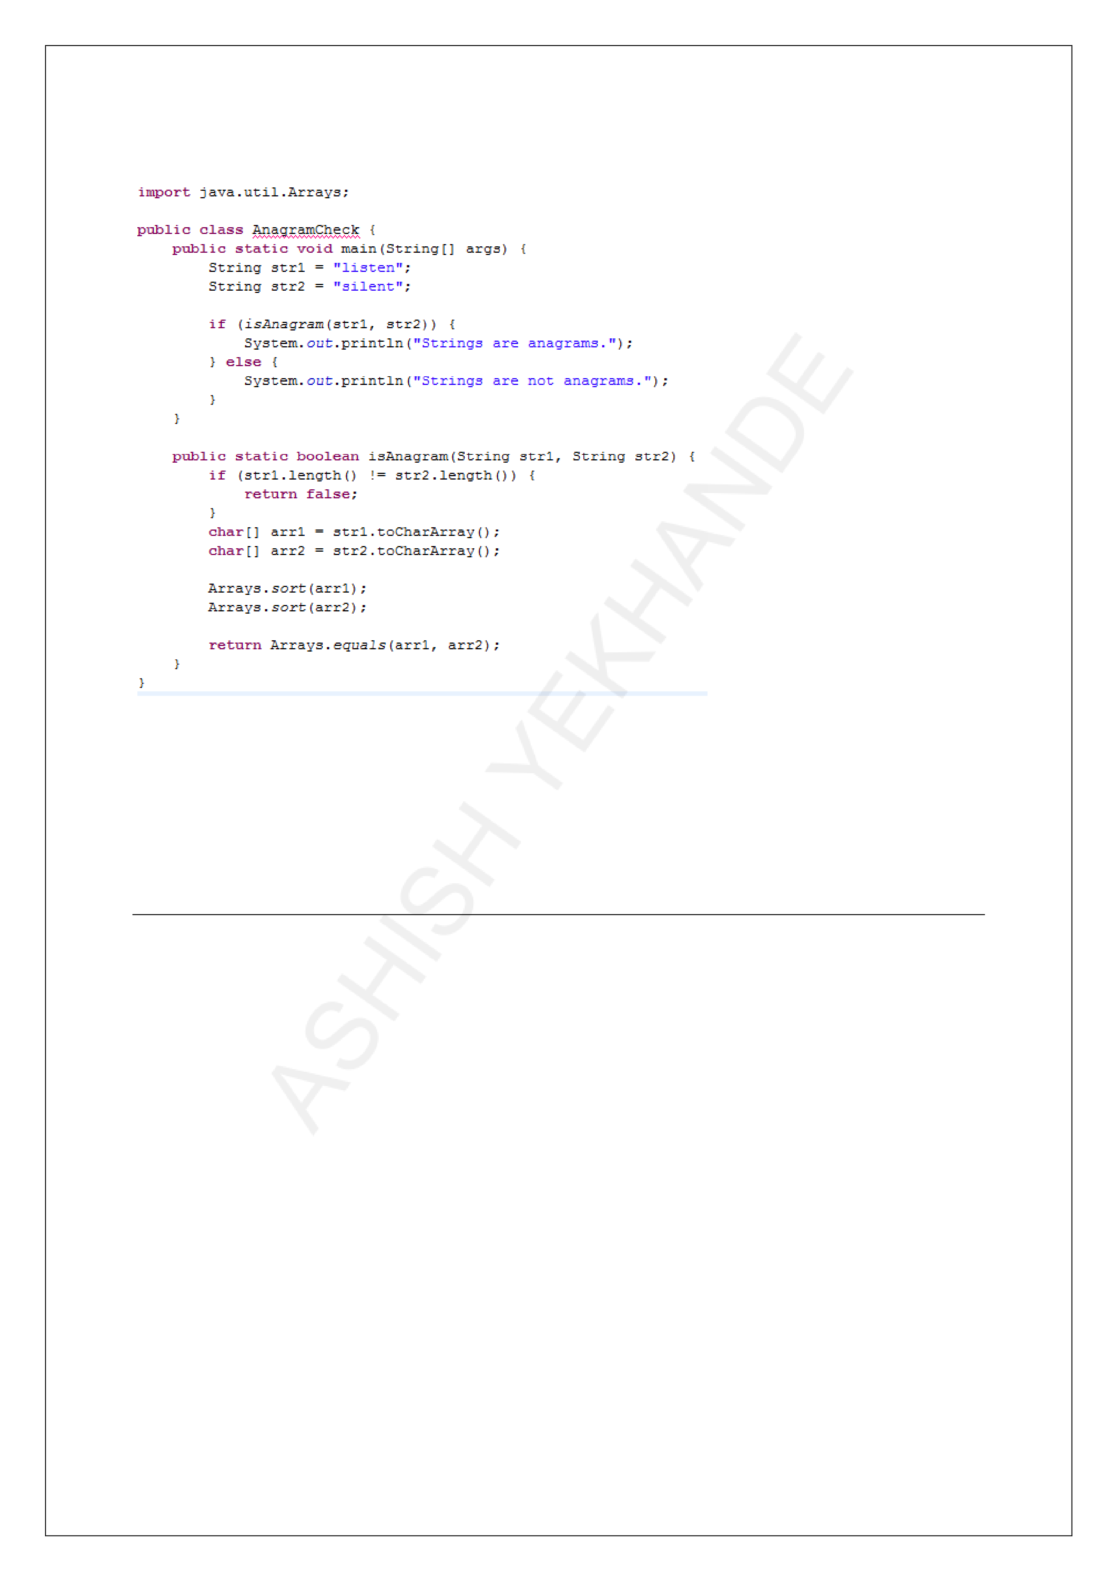

**IMPORTANT JAVA PROGRAMS BASED ON STRING**

**Check if two strings are anagrams**

**Explanation**:

|  |  |
| --- | --- |
| •  •  • | **if (str1.length() != str2.length())**: Checks if both strings have the same length.  **Arrays.sort(arr1)**: Sorts the character array of the first string.  **Arrays.equals(arr1, arr2)**: Compares the sorted character arrays of both strings. |

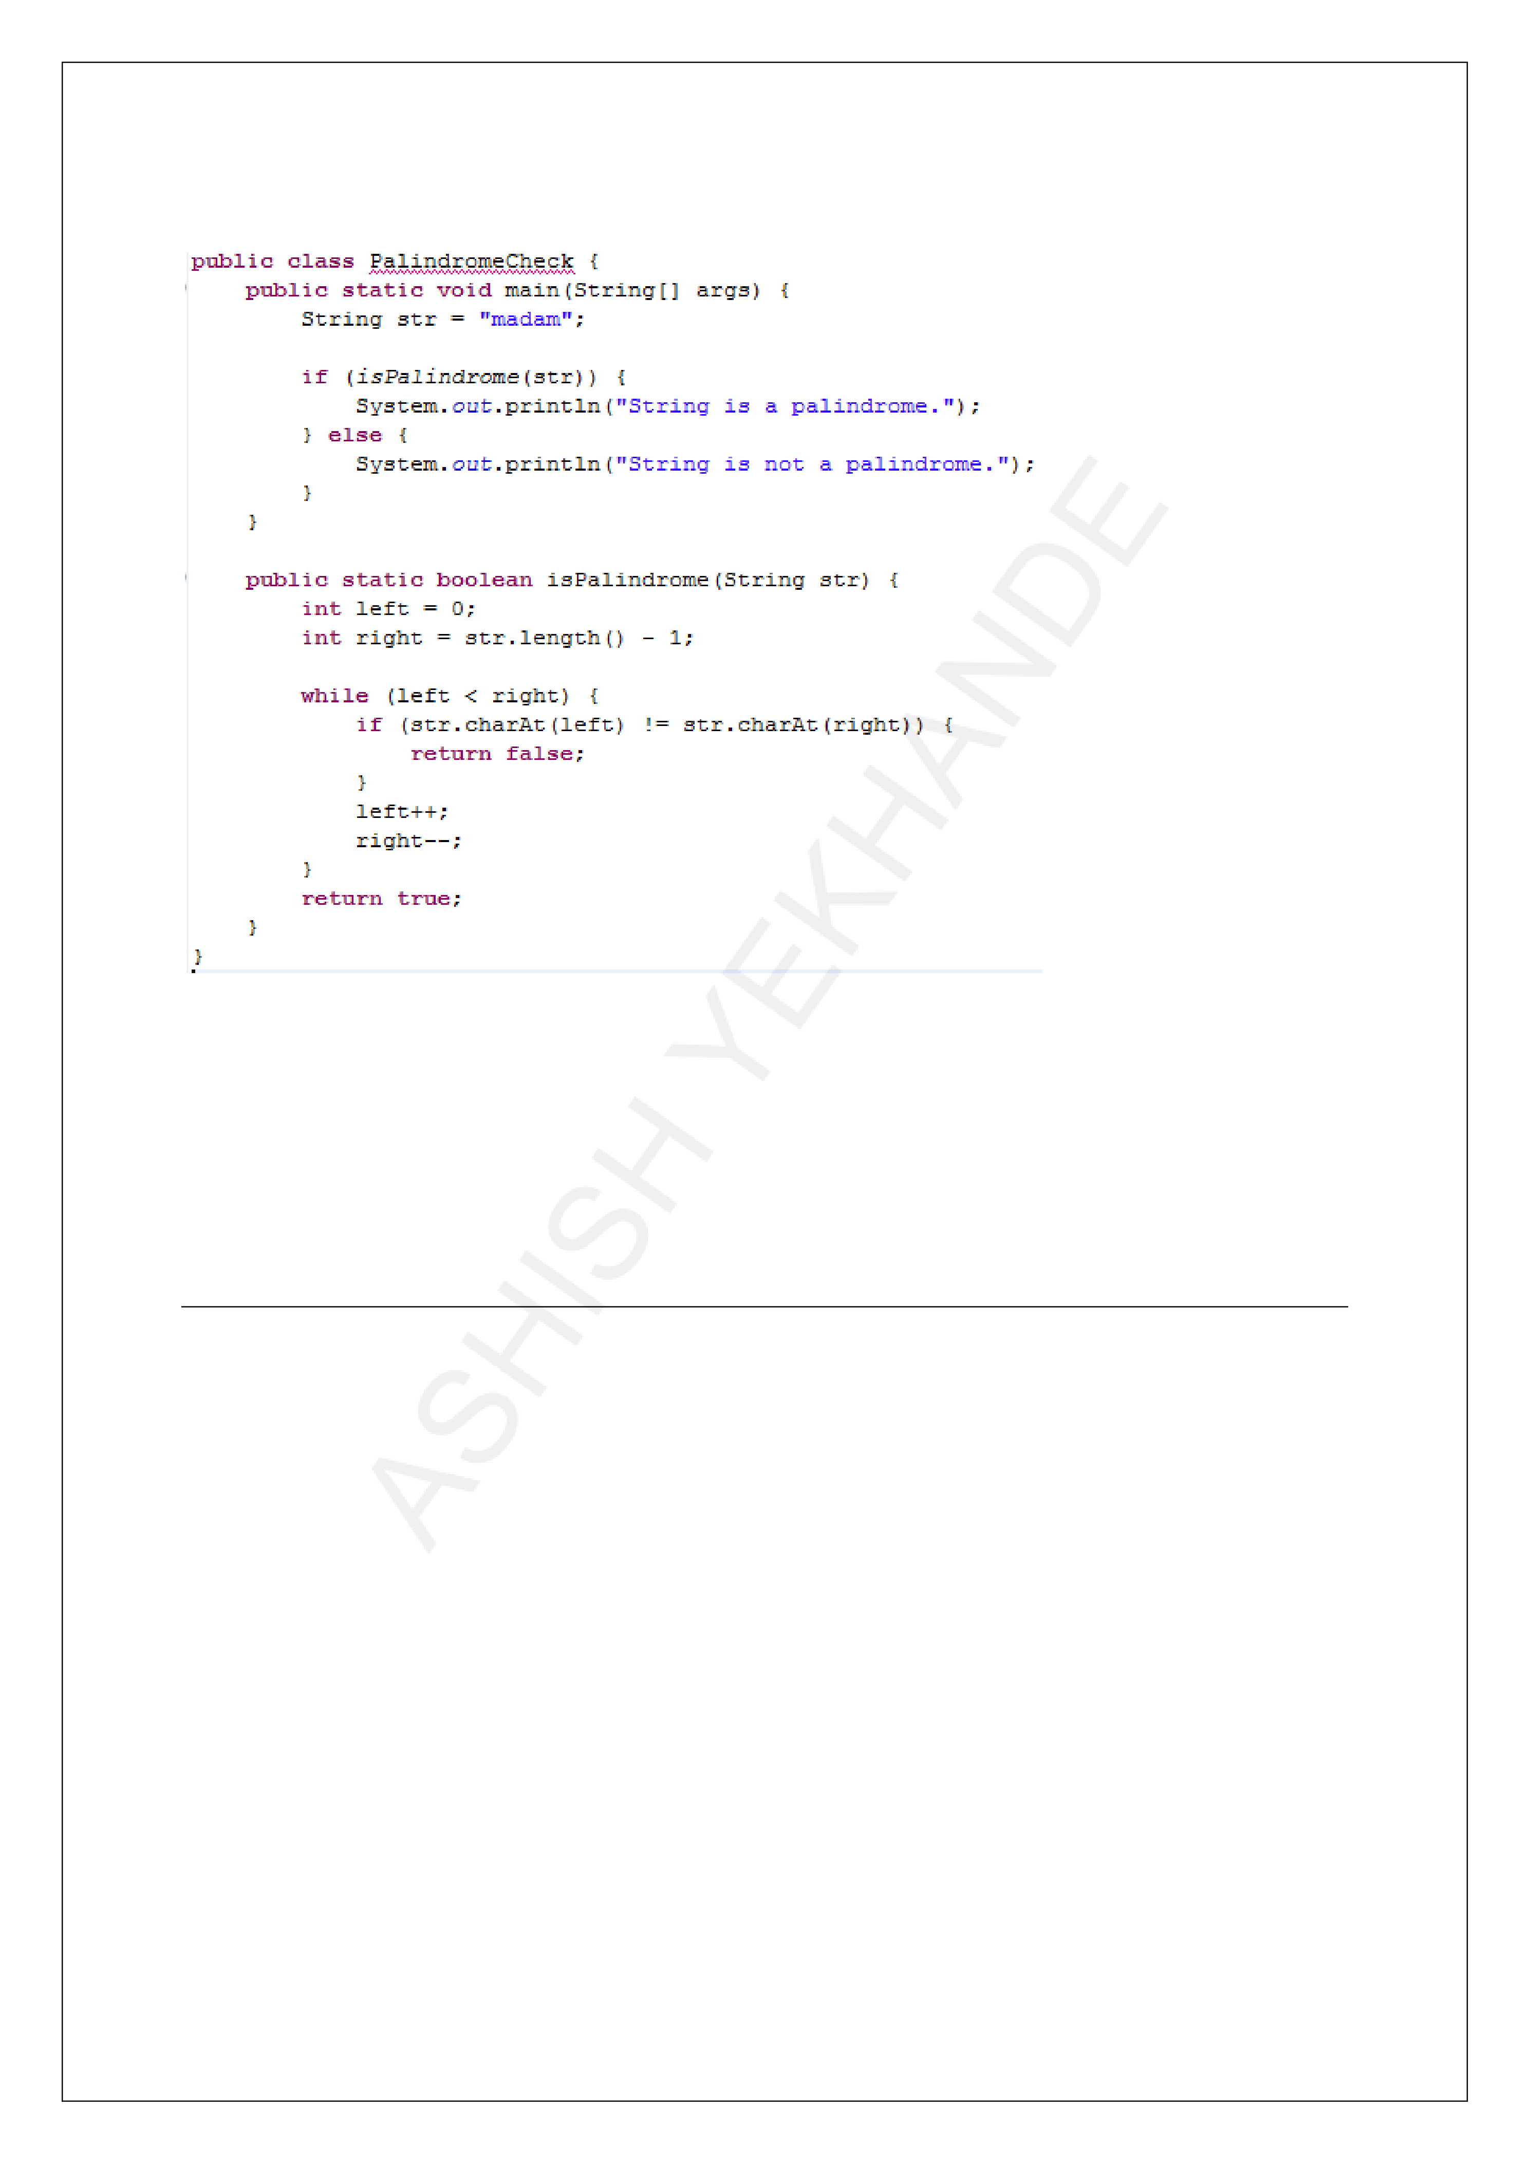

**IMPORTANT JAVA PROGRAMS BASED ON STRING**

**Check if a string is a palindrome**

**Explanation**:

|  |  |
| --- | --- |
| • | **while (left < right)**: Loops through the string comparing characters from the start |

and end.

|  |  |
| --- | --- |
| • | **str.charAt(left) != str.charAt(right)**: If characters don't match, it's not a |

palindrome.

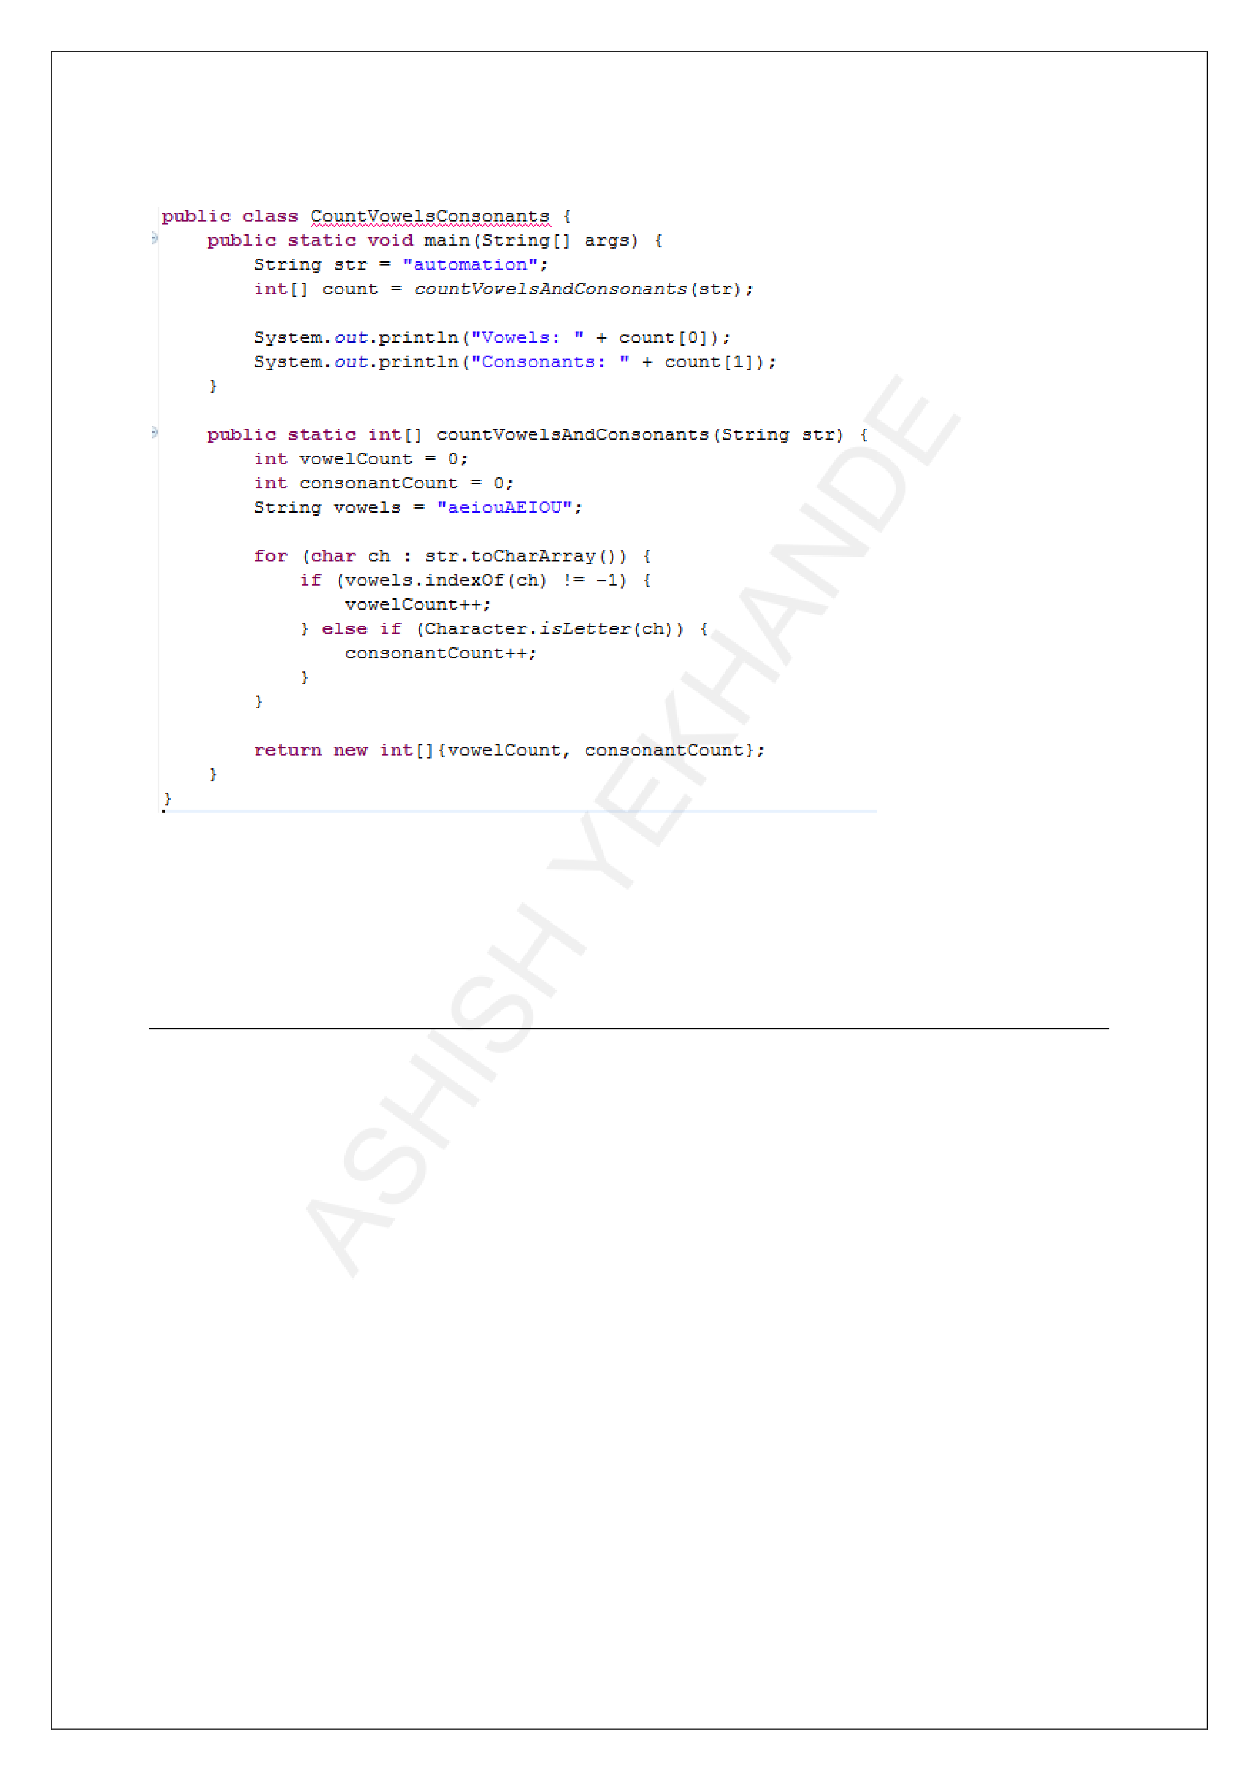

**IMPORTANT JAVA PROGRAMS BASED ON STRING**

**Count the number of vowels and consonants in a string**

**Explanation**:

|  |  |
| --- | --- |
| •  • | **vowels.indexOf(ch) != -1**: Checks if the character is a vowel.  **Character.isLetter(ch)**: Ensures that only letters are counted as consonants. |

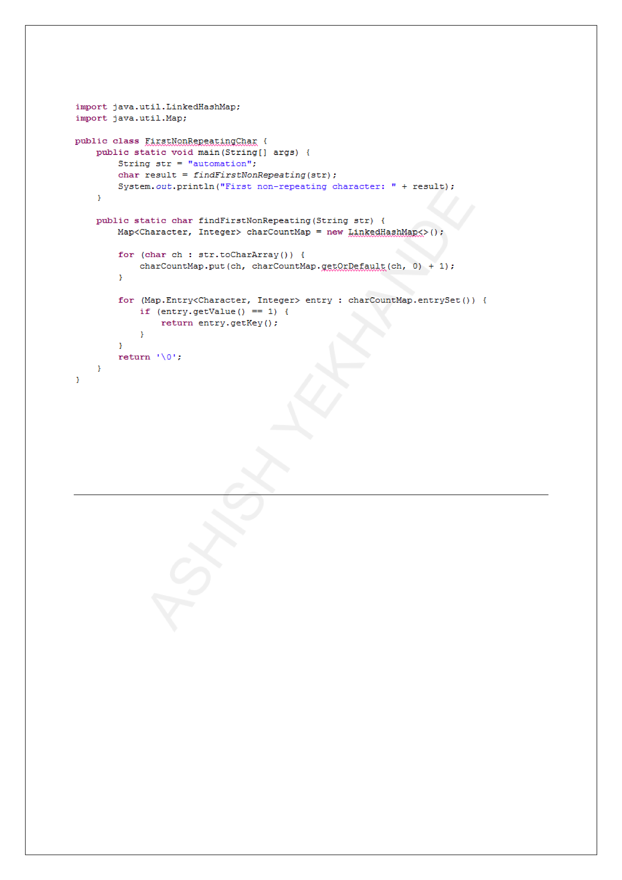

**IMPORTANT JAVA PROGRAMS BASED ON STRING**

**Find the first non-repeating character in a string**

**Explanation**:

|  |  |
| --- | --- |
| •  • | **charCountMap.getOrDefault(ch, 0) + 1**: Increments the count of each character.  **if (entry.getValue() == 1)**: Finds the first character that appears only once. |

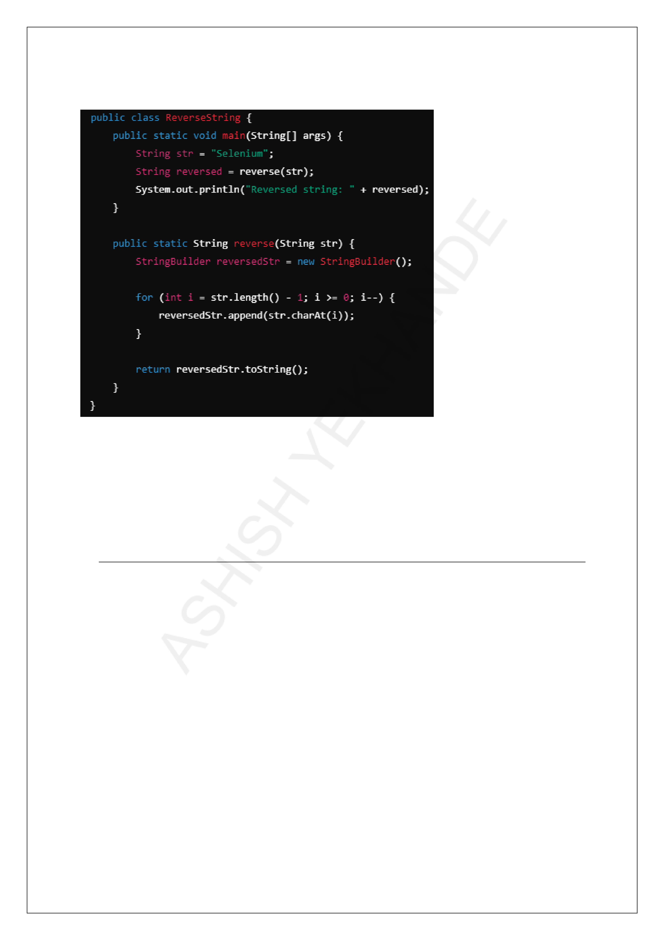

**IMPORTANT JAVA PROGRAMS BASED ON STRING**

**Reverse a string**

**Explanation**:

|  |  |
| --- | --- |
| • | **for (int i = str.length() - 1; i >= 0; i--)**: Loops through the string from the end to |

the beginning.

|  |  |
| --- | --- |
| • | **reversedStr.append(str.charAt(i))**: Appends each character to the reversed |

string.

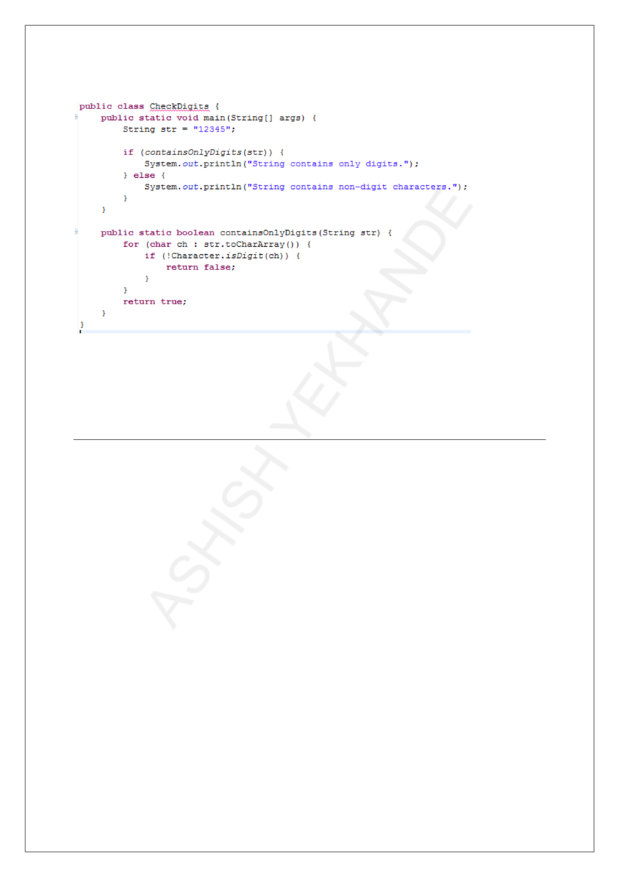

**IMPORTANT JAVA PROGRAMS BASED ON STRING**

**Check if a string contains only digits**

**Explanation**:

|  |  |
| --- | --- |
| •  • | **Character.isDigit(ch)**: Checks if each character is a digit.  If any character is not a digit, it returns false. |

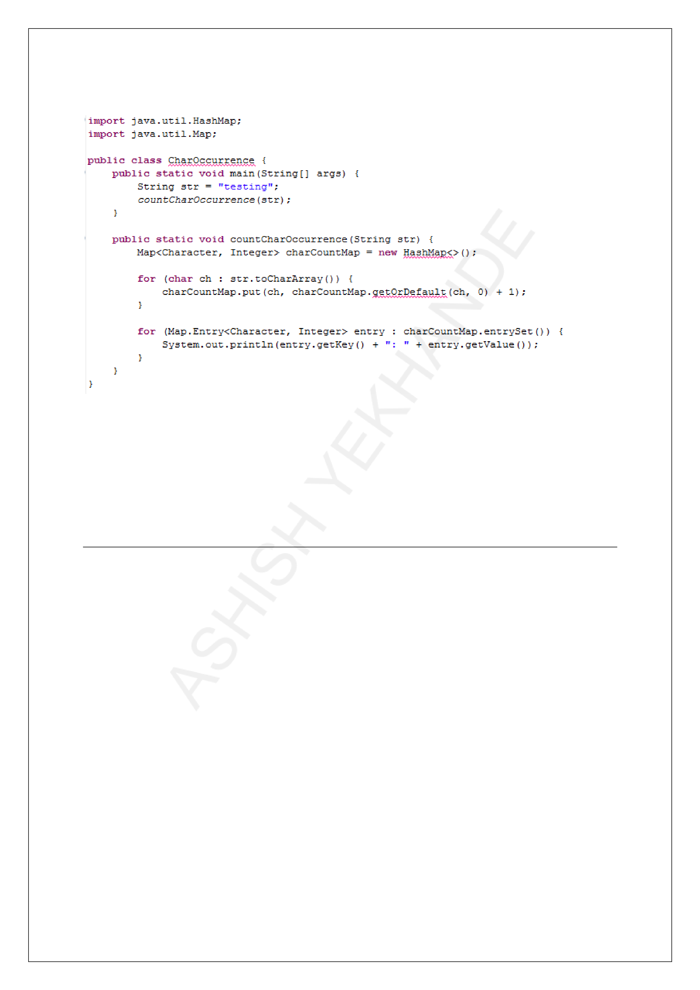

**IMPORTANT JAVA PROGRAMS BASED ON STRING**

**Count the occurrence of each character in a string**

**Explanation**:

|  |  |
| --- | --- |
| • | **charCountMap.put(ch, charCountMap.getOrDefault(ch, 0) + 1)**: Increments the |

count of each character.

|  |  |
| --- | --- |
| • | **for (Map.Entry<Character, Integer> entry)**: Iterates through the map to print the |

count of each character.

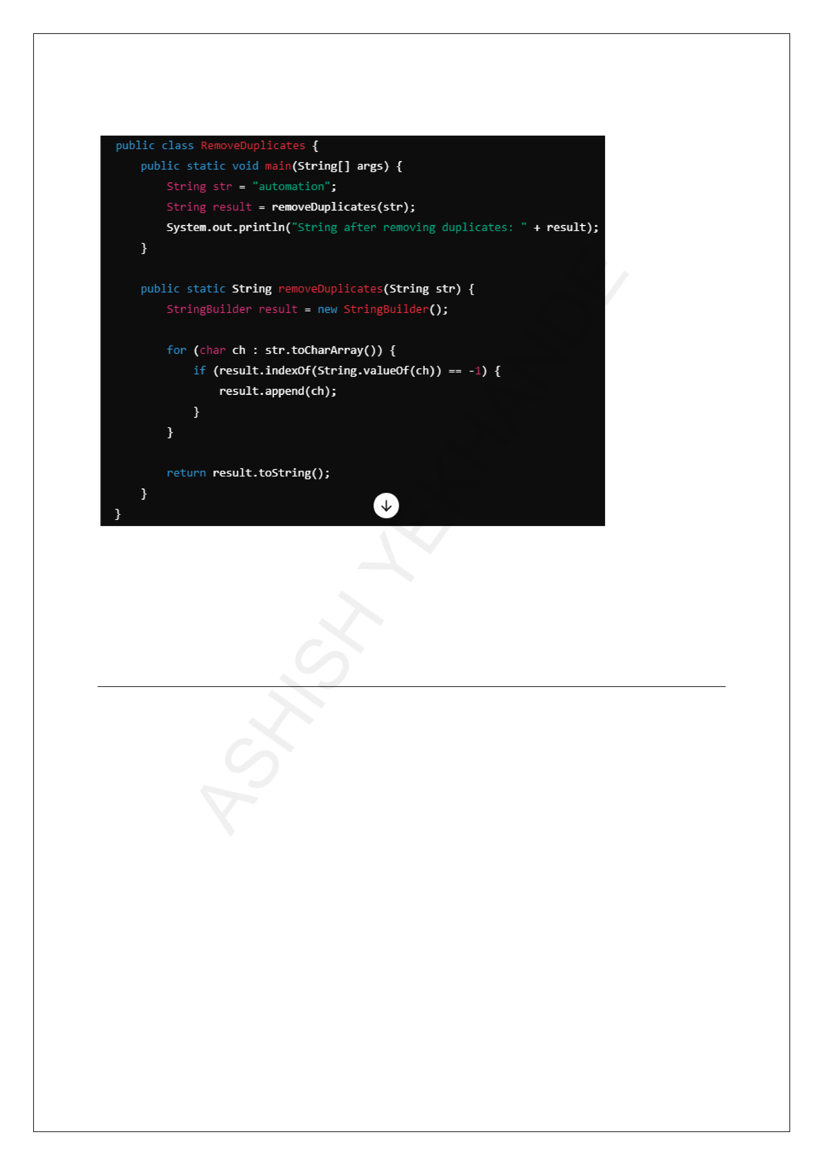

**IMPORTANT JAVA PROGRAMS BASED ON STRING**

**Remove duplicate characters from a string**

**Explanation**:

|  |  |
| --- | --- |
| • | **result.indexOf(String.valueOf(ch)) == -1**: Checks if the character is already |

present in the result.

|  |  |
| --- | --- |
| • | If not present, the character is appended to the result. |

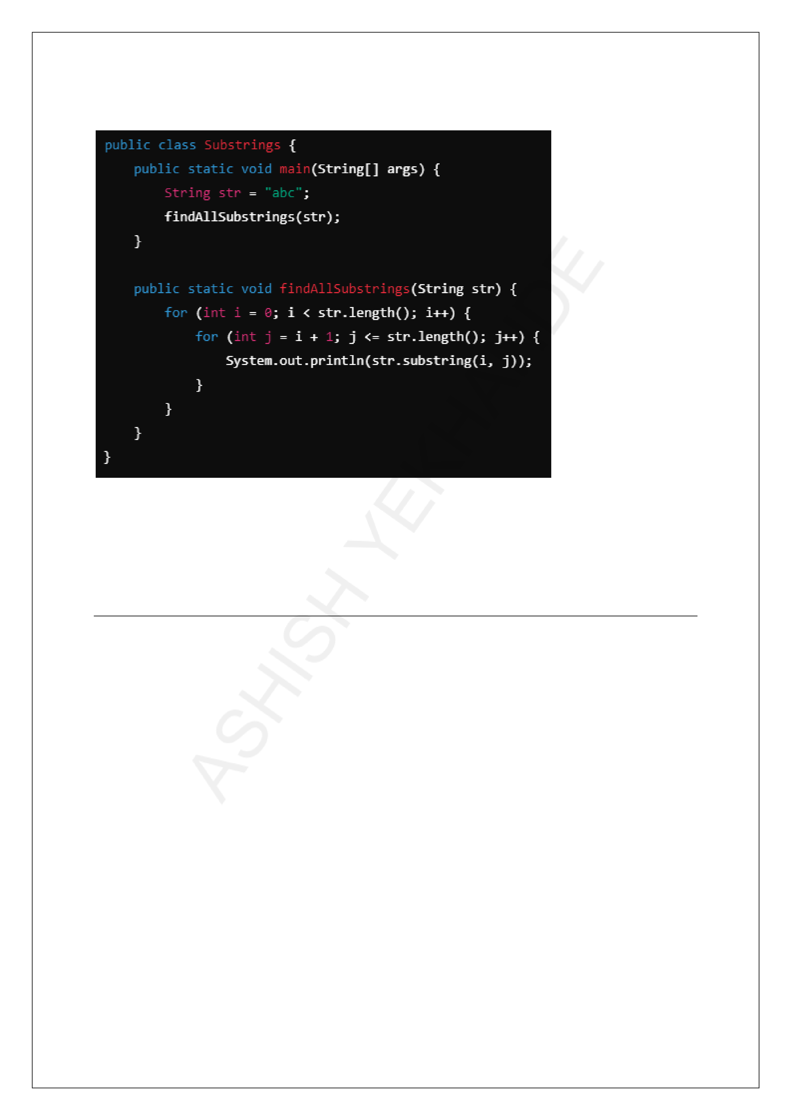

**IMPORTANT JAVA PROGRAMS BASED ON STRING**

**Find all substrings of a string**

**Explanation**:

|  |  |
| --- | --- |
| •  • | **str.substring(i, j)**: Extracts all substrings starting from index i to j.  Nested loops ensure that all possible substrings are printed. |

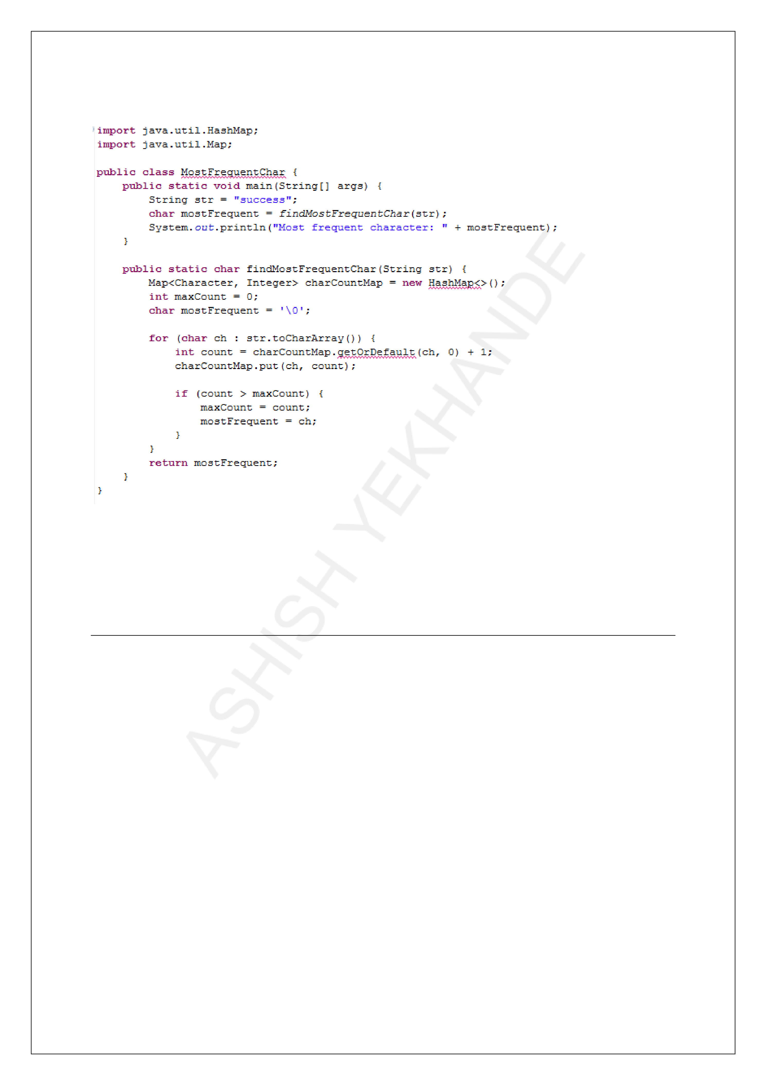

**IMPORTANT JAVA PROGRAMS BASED ON STRING**

**Find the most frequent character in a string**

**Explanation**:

|  |  |
| --- | --- |
| •  • | **if (count > maxCount)**: Tracks the character with the highest frequency.  Updates the most frequent character during iteration. |

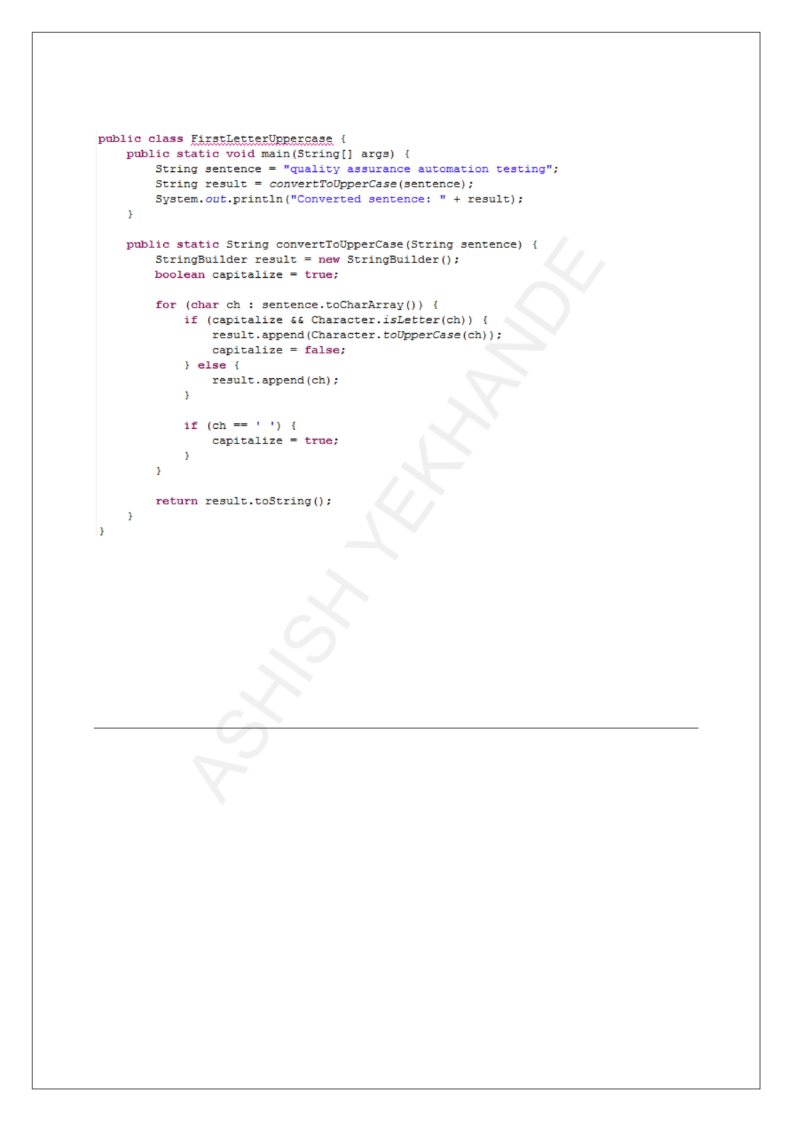

**IMPORTANT JAVA PROGRAMS BASED ON STRING**

**Convert the first letter of each word in a string to uppercase**

**Explanation**:

|  |  |
| --- | --- |
| •  • | **boolean capitalize = true**: A flag to indicate when to capitalize a letter.  **Character.toUpperCase(ch)**: Converts the character to uppercase if it is the first |

letter of a word.

|  |  |
| --- | --- |
| • | The flag is reset after every space character, allowing the first letter of the next word |

to be capitalized.